1. *How do you create a table using SQL?* 
   1. CREATE TABLE TABLE_NAME (COLUMN_NAME DATA_TYPE)
2. *How do you delete a table using SQL?* 
   1. DROP TABLE TABLE_NAME
3. *What are the common data types used to define columns using SQL?* 
   1. VARCHAR, CHAR, INT, DECIMAL, DATE, SQL_VARIANT

4. *Identify the best data type to use to store the following data in Oracle, in SQL Server, and in Access:a. The month, day, and year that an employee was hired*

DATE

*b. An employee’s Social Security number*

VARCHAR(256) (not just because we may store “-“s, we could store hashed values that include long strings of characters and numbers)

*c. The department in which an employee works*

VARCHAR

*d. An employee’s hourly pay rate*

DECIMAL

*5. Identify the following column names as valid or invalid in Oracle:a. COMMISSIONRATE*

*b. POSTAL_CODE_5CHAR*

*c. SHIP TO ADDRESS*

*d. INVOICE-NUMBER*

*6.What is a null value? How do you use SQL to identify columns that cannot accept null values?*

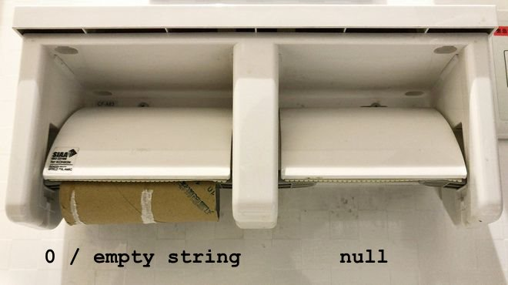

Null is the ABSENCE of value. NOT NULL is a property that can be assigned to make value input mandatory.

*7. Which SQL command do you use to add a row to a table?*

INSERT

*8. Which SQL command do you use to view the data in a table?*

SELECT

*9. Which SQL command do you use to change the value in a column in a table?*ALTER

*10. Which SQL command do you use to delete rows from a table?*DELETE

*11. How do you display the columns in a table and their characteristics in Oracle?*DESCRIBE

*12. Explain the difference between the CHAR data type and the VARCHAR data type. Use the Internet to find examples of when to use VARCHAR and when to use CHAR. Be sure to cite the URL(s) that provided the examples as references at the end of your document.*

CHAR is a fixed size character storage type limited to 1 and 8000 bytes, while VARCHAR is a variable character storage type that may store up to 2GB if we pass the MAX argument.

https://docs.microsoft.com/en-us/sql/t-sql/data-types/char-and-varchar-transact-sql?view=sql-server-ver15

*13. Use the Internet to research BOOLEAN data types. What is a BOOLEAN data type and what is it called in Oracle, SQL Server, and Access? Be sure to cite the URL(s) that provided the information at the end of your document.*

Boolean datatypes are logical TRUE or FALSE values. 1 or 0. Oracle, in it’s infinite wisdom, does not support Boolean types, so we have to be a little hacky. Char(1) and storing Y/N or 1/0 is common.

<https://stackoverflow.com/questions/3726758/is-there-any-boolean-type-in-oracle-databases#3726846>

“Enjoy Oracle!”